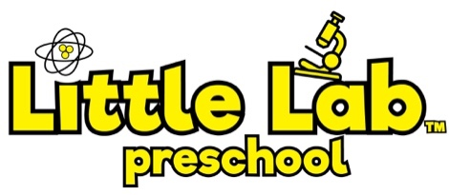
970.223.3939
littlelabpreschool@aol.com
LittleLabPreschool.com
Little Lab™ Preschool
3533 Riva Ridge Drive
Fort Collins, CO 80526

Dear Little Lab™ Families,

Thank you for choosing Little Lab™ Preschool and Child Care for your early educational and child care needs! We are proud to offer a unique Science and Math curriculum that promotes critical thinking, problem solving, and literacy skills. Little Lab™ Preschool and Child Care accepts children of all abilities between the ages of 2 ½ and 6 years.

Enclosed in this package you will find the paperwork necessary for enrollment at Little Lab™ Preschool. The importance of this paperwork requires that it be completed before your child can attend. If there is a delay in getting some of this completed, please let the Director know and we will do our best to help.

Application: This needs to be completed by the child’s parents or legal guardians. The Emergency Contact listed on this form will have permission to pick up your child if or when you are unable to do so. This person needs to be in the local area in the event they need to pick up your child and they need to be someone other than the child’s parents or legal guardians.

Health Form: This is an important form for you and for us. Please have this completed and signed by your child’s physician and indicate that your child has had a well check in the past 12 months. The State of Colorado requires that you provide this form annually in order for enrollment to continue.

Emergency Card: This is also important for us as it gives us a quick look at important information in the event of an emergency. Please complete the enclosed card in full. In the event there are changes throughout the year, please let the Director know and we/you will make the appropriate changes on that card.

Immunization Records: These records must be maintained on the provided State form and kept up to date for every child. Please make any necessary changes to your child’s vaccinations status as needed throughout their enrollment at our school.

FYI: We are a NUT AND PEANUT FREE school! As a safety precaution for all who attend Little Lab™ Preschool and Child Care we ask that you do not bring any nuts or peanuts into our school. Also, please make sure that your child arrives at school with no nut/peanut residue on clothes, hands and face.

We look forward to working with your family and providing the best care and education we can offer!

Sincerely,

Ernie Batson, M.A.
Owner

.

